# System Architecture – Smart Logistics Automation

## 1. Overview
This automation system replaces manual spreadsheet operations with Telegram-based commands and automated workflows.

## 2. Components
- Telegram Bot → User interface
- n8n → Workflow engine
- Excel → Lightweight database
- Gmail API → Reminder automation
- Lovable → Dashboard visualization

## 3. Core Automations
- GET revenue, dispatch details, inventory
- UPDATE sheet data via command
- DELETE row operations
- SEND auto-email reminders

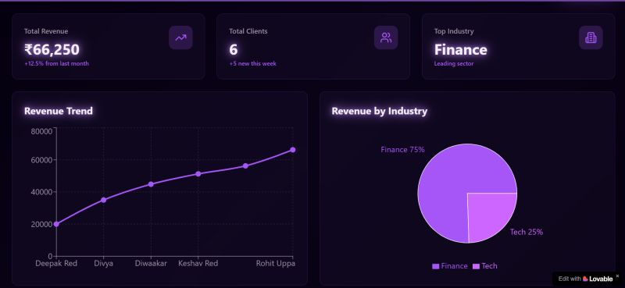
## 4. Workflow Screenshots

